1. Why python is famous.

First and foremost reason why Python is much popular because **it is highly productive as compared** to other programming languages like C++ and Java. ... Python is also very famous for its simple programming syntax, code readability and English-like commands that make coding in Python lot easier and efficient.

* Easy to Read, Learn and Write. Python is a high-level programming language that has English-like syntax. ...
* Improved Productivity.
* Interpreted Language. ...
* Dynamically Typed. ...
* Free and Open-Source.
* Vast Libraries Support. ...
* Portability. ...
* Slow Speed.

1. why python is better than other languages

The python language is one of the most accessible programming languages available because it has **simplified syntax and not complicated**, which gives more emphasis on natural language. Due to its ease of learning and usage, python codes can be easily written and executed much faster than other programming languages.

1. Compiler or Intepreter

Both compilers and interpreters are used to convert a program written in a high-level language into machine code understood by computers. However, there are differences between how an interpreter and a compiler works.

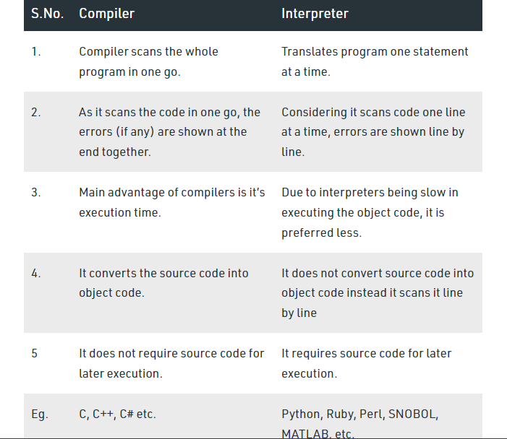

Python – interpreted language , object oriented language.

1. ASCII

ASCII stands for American Standard Code for Information Interchange. It is a character encoding standard that **uses numbers from 0 to 127** to represent English characters. For example, ASCII code for the character A is 65, and 90 is for Z.

# What is a Variable in Python?

A Python variable is a reserved memory location to store values. In other words, a variable in a python program gives data to the computer for processing.

Every value in Python has a datatype. Different data types in Python are Numbers, List, Tuple, Strings, Dictionary, etc. Variables can be declared by any name or even alphabets like a, aa, abc, etc

# Variable Naming Rules in Python

1. Variable name should start with letter(a-zA-Z) or underscore (_). Valid : age , _age , Age

Invalid : 1age

1. In variable name, no special characters allowed other than underscore (_). Valid : age_ , _age

Invalid : age_*

1. Variables are case sensitive.

age and Age are different, since variable names are case sensitive. 4.Variable name can have numbers but not at the beginning.

Example: Age1

5.Variable name should not be a Python keyword.Keywords are also called as reserved words.

Example

pass, break, continue.. etc are reserved for special meaning in Python. So, we should not declare keyword as a variable name.